**Document – Chart Details**

**For pH and Weight Prediction:**

For R&D purpose simulated data of 9 Hours production process where the Reading is taken at every 1 Hour is taken into account 100 such experiment is simulated and the mean of such whole process cycle are taken for building ML Models. For predicting pH, the model that gave best performance is Linear Regression and for Weight is Random Forest.

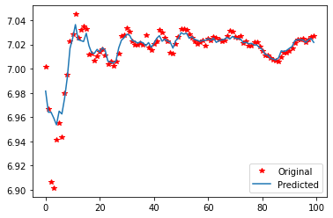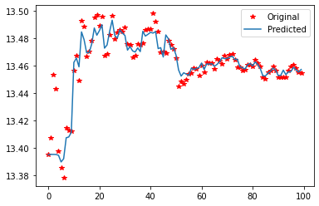

1. Kindly refer cell no. 16 in ‘Chemica_Reactor_Regression.ipynb’ for pH prediction and Excel file 'Model_prediction_for_pH.xlsx' for stored prediction results. The prediction is done through model.predict() function of the respective Model

2. Kindly refer cell no. 15 in ‘Chemica_Reactor_Regression.ipynb’ for Weight prediction and Excel file 'Model_prediction_for_Weight.xlsx' for stored prediction results. The prediction is done through model.predict() function of the respective Model is the graph of original and predicted y’s. The x-axis is the experiment number

**The x-axis is the number of Experiment and the y-axis is pH, Weight**

**For Control Chart:**

The data simulated for the simulation is a 3 Hour experiment where the readings are taken every minute so 180 records. This python file is for generating the dataset for all four parameters of Chemical Reactor for Individual parameter control chart and all parameter reactor stability index**. The x- axis for the Control chart is the Time (Minute Number) and on y-axis the input data, ucl and lcl for the parameter.**   
 'df_control_chart_chemical_reactor' DataFrame contains values of all the parameters necessary for individual control charts Kindly refer to Cell No.27 and Excel file ‘control_chart_dataset.xlsx' for stored data.

For ‘runtime_stability_index' DataFrame contains parameters values for Chemical Reactor Stability Index. Kindly refer to Cell No.25 and Excel file ‘reactor_stability_index_dataset.xlsx’ for stored data. **The x-axis is 5-minute runtime (So for 3 Hours there are 36, 5-minute intervals) interval and the y-axis is the runtime stability index (calculated for the python file Kindly refer cell no. 24 in ‘Control Chart and Reactor Stability Index.ipynb’)**